

**Faculty of engineering - Shoubra**

**Benha University**

**Research Article / Research Project / Literature Review**

in fulfillment of the requirements of

|  |  |
| --- | --- |
| **Department** | Engineering Mathematics and Physics |
| **Division** | **--------------** |
| **Academic Year** | 2019-2020 Preparatory |
| **Course name** | **Computer** |
| **Course code** | **ECE001** |

**Title:**

**Programming Languages**

By:

|  |  |  |  |
| --- | --- | --- | --- |
|  | Name | Edu mail | B.N |
| 1 | عمر شعبان ربيع على | Omar195609@feng.bu.edu.eg | 549 |

Github-link: <https://github.com/omar-shaaban/ece001>

<https://omar-shaaban.github.io/ece001/>

**Approved by:**

|  |  |
| --- | --- |
| Examiners committee | Signature |
| Dr.Ahmed Bayoumi |  |
| Dr.Shady Elmashad |  |
| Dr. Abdelhamid Attaby |  |
|  |  |
|  |  |

Programming languages

A programming language is a formal language comprising a set of instructions that produce various kinds of output. Programming languages are used in computer programming to implement algorithms.

Thousands of different programming languages have been created, and more are being created every year. Many programming languages are written in an imperative form (i.e., as a sequence of operations to perform) while other languages use the declarative form (i.e. the desired result is specified, not how to achieve it).

The description of a programming language is usually split into the two components of syntax (form) and semantics (meaning). Some languages are defined by a specification document (for example, the C programming language is specified by an ISO Standard) while other languages (such as Perl) have a dominant implementation that is treated as a reference. Some languages have both, with the basic language defined by a standard and extensions taken from the dominant implementation being common.

Screenshots:

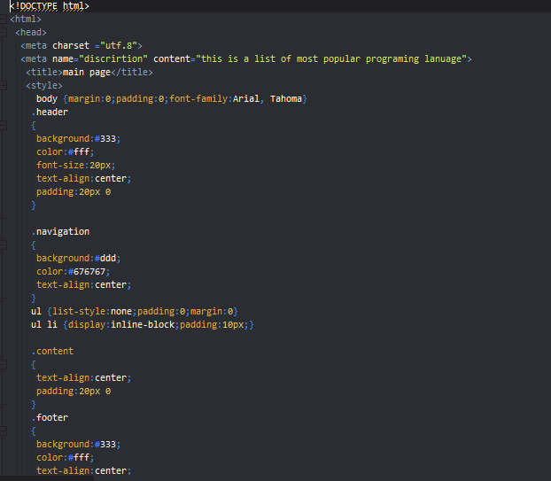1-mainpage file:///D:/html%20project/mainpage.html

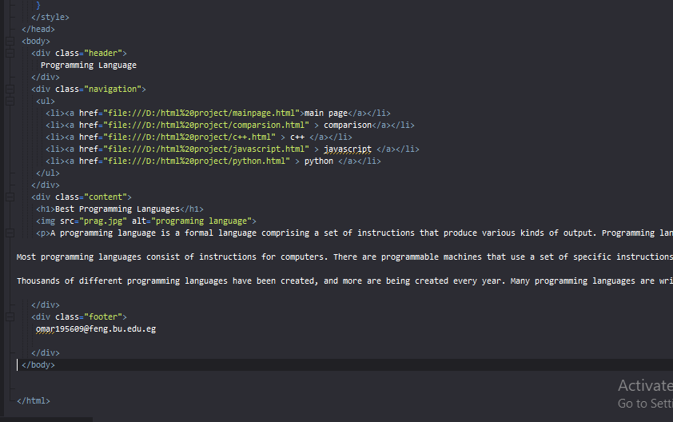

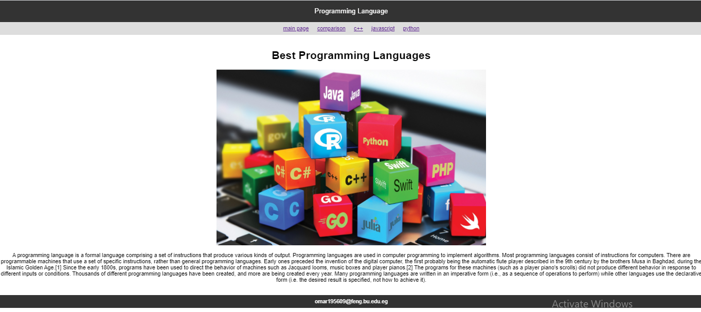

2-comparison file:///D:/html%20project/comparsion.html

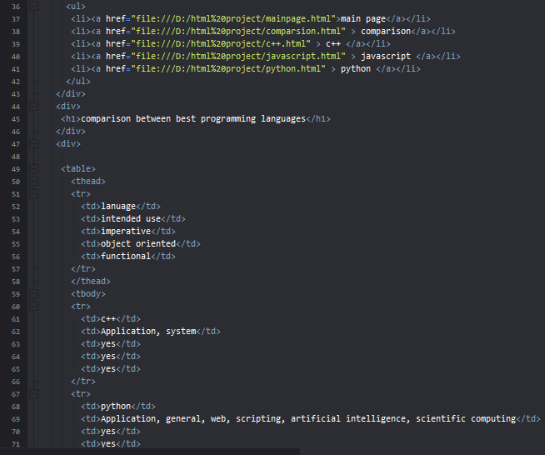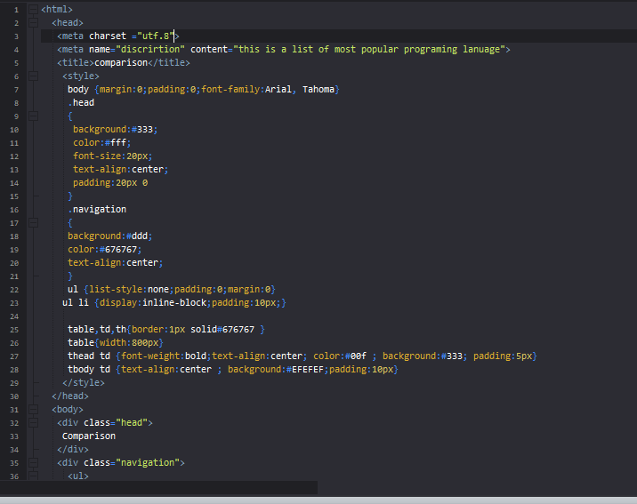

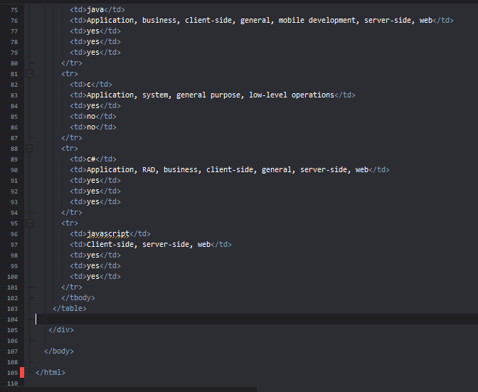

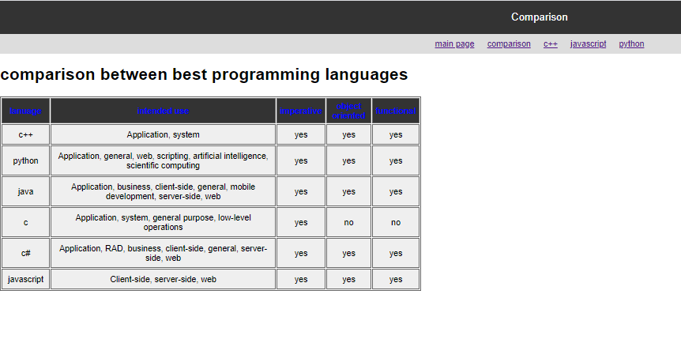

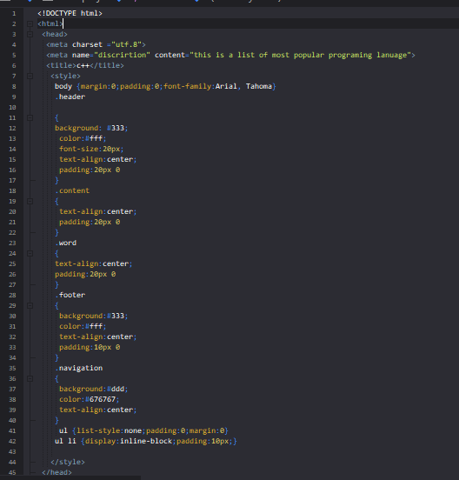3-c++language file:///D:/html%20project/c++.html

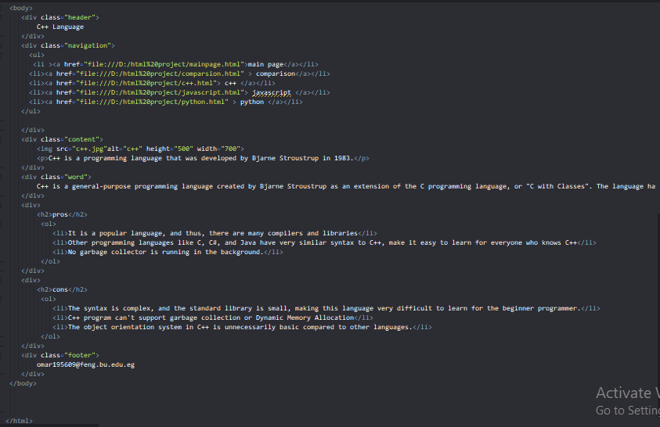

4-javacript language file:///D:/html%20project/javascript.html

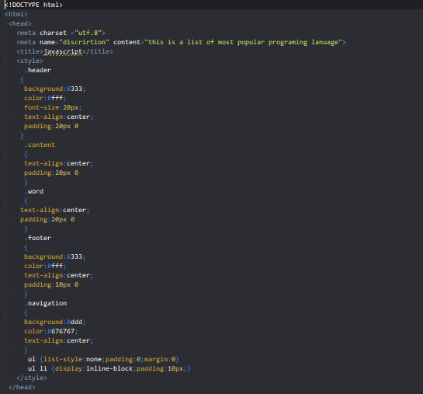

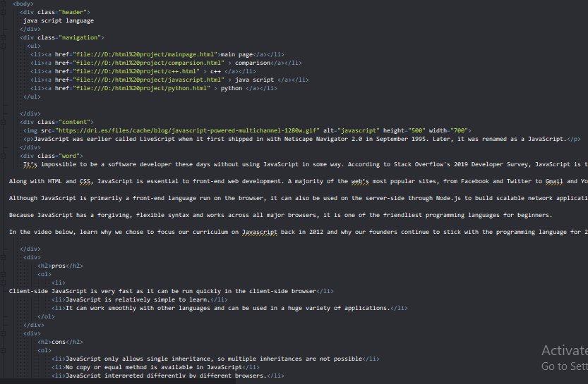

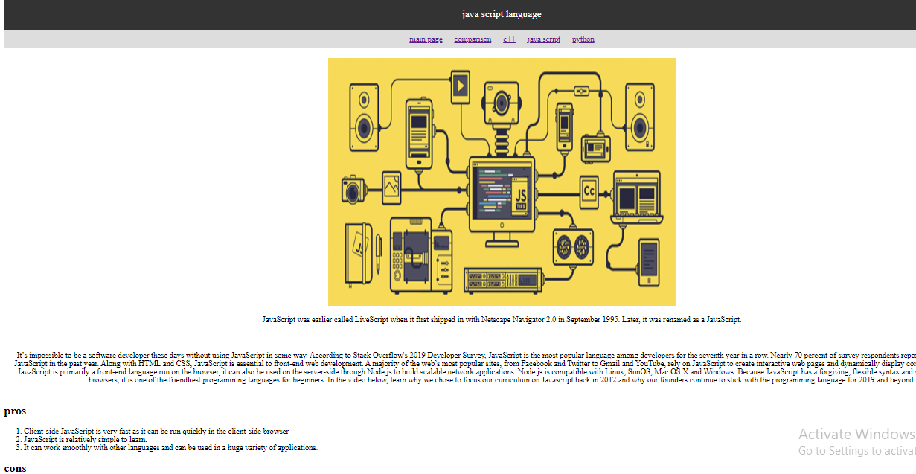

5-python language file:///D:/html%20project/python.html

